

2026
Nigerian Capital
Markets Outlook
Real Rates, Real Returns: Nigeria’s Rate Turn and What It Means
[ COVER IMAGE ]
Lagos skyline, financial district, or abstract data visualization

February 2026
Lagos, Nigeria | Hamilton, Bermuda
venoble.com

Table of Contents
Right-click here and select “Update Field” to generate the Table of Contents.


Letter from the CEO
────────────────────
Dear Reader,
I have a confession. When we started building Venoble, there were days I wasn’t sure the timing was right. Nigeria’s capital markets can be difficult to love. Liquidity dries up without warning. Policy shifts at the speed of a single MPC communiqué. The data infrastructure that investors in London or New York take for granted simply does not exist here yet. But I kept coming back to a question that wouldn’t leave me alone: if not now, when?
Something is changing. You can see it in the pension funds that have quadrupled their equity allocations in three years. You can see it in the foreign capital that returned at a pace nobody expected. You can see it in the conversations I’m having. Not just with fund managers on the Island, but with a 26-year-old in Abuja who opened a brokerage account for the first time last quarter because, for the first time, the returns were impossible to ignore.
That is the story of 2026 for me. Not the macro numbers. You’ll find those in the pages that follow, and they’re encouraging. It’s the participation. More Nigerians are entering the capital markets than at any point I can remember. The NGX crossed ₦125 trillion in market capitalisation. The real question is what happens when the next wave arrives: the retail investors, the diaspora capital, the pension money still sitting in fixed deposits earning negative real returns.
I believe Nigeria is at the front of something larger. A new generation of African economies is emerging: reform-minded, young, and increasingly connected to global capital flows. Nigeria has the ingredients that matter: a $25 billion annual remittance corridor, a refinery that will reshape the country’s external balance, and a technology ecosystem already producing global companies. What’s been missing is the market infrastructure to channel all of this into long-term wealth creation. That gap is closing. Fast.
We don’t have all the answers. We got the naira call wrong in the second half of last year, and the February rate cut caught us off guard. This Outlook is honest about where our conviction is high and where it isn’t. We built the VNG-CRR Index, our cash real return benchmark, because we believe Nigerian investors deserve better tools to measure what their money is actually doing. That same belief drives everything in this report.
Thank you for reading. I hope you find something here that changes how you think about the year ahead.
“The question is no longer whether Nigeria’s capital markets will mature. It’s whether you’ll be positioned when they do.”

E.J. Ibhawoh  Founder & CEO, Venoble Limited  February 2026 | 

Executive Summary
KEY CALLS FOR 2026
1 GDP growth of 4.2% (base case), driven by non-oil recovery and Dangote refinery contribution.
2 Headline inflation to decelerate to c.13% by year-end. Food CPI already at 8.89%, a 10-year low.
3 CBN easing cycle underway (27.5% to 26.5%), with 200–300bps of further cuts expected through 2026.
4 Naira to trade ₦1,450–1,550/USD on NAFEM (base case), supported by $50bn+ reserves.
5 NGX All-Share Index to deliver 30–40% total return, led by banking recapitalisation and PenCom flows.
6 Real yields on T-bills positive for the first sustained period since 2019 (VNG-CRR confirms).

Macro Overview
Nigeria’s economy printed 3.98% growth in Q3 2025, accelerating from 2.54% two years earlier. Headline inflation collapsed from 34.80% (Dec 2024) to 15.10% (Jan 2026), with food CPI hitting single digits for the first time in over a decade. Cardoso cut the MPR 50bp to 26.5% in February 2026. The hard part of the reform cycle (subsidy removal, Naira float, tax overhaul) is done. The question for 2026 is whether the payoff arrives in asset prices.

Capital Markets Outlook
Fixed income is our highest-conviction overweight. The easing cycle creates a once-in-a-cycle duration opportunity in FGN bonds, and the Feb 18 NTB auction saw 364-day rates fall below 16% for the first time. We favour the 5–10Y belly of the curve. The biggest risk to the entire thesis is an oil price shock below $55 that reverses the fiscal and FX improvement simultaneously.
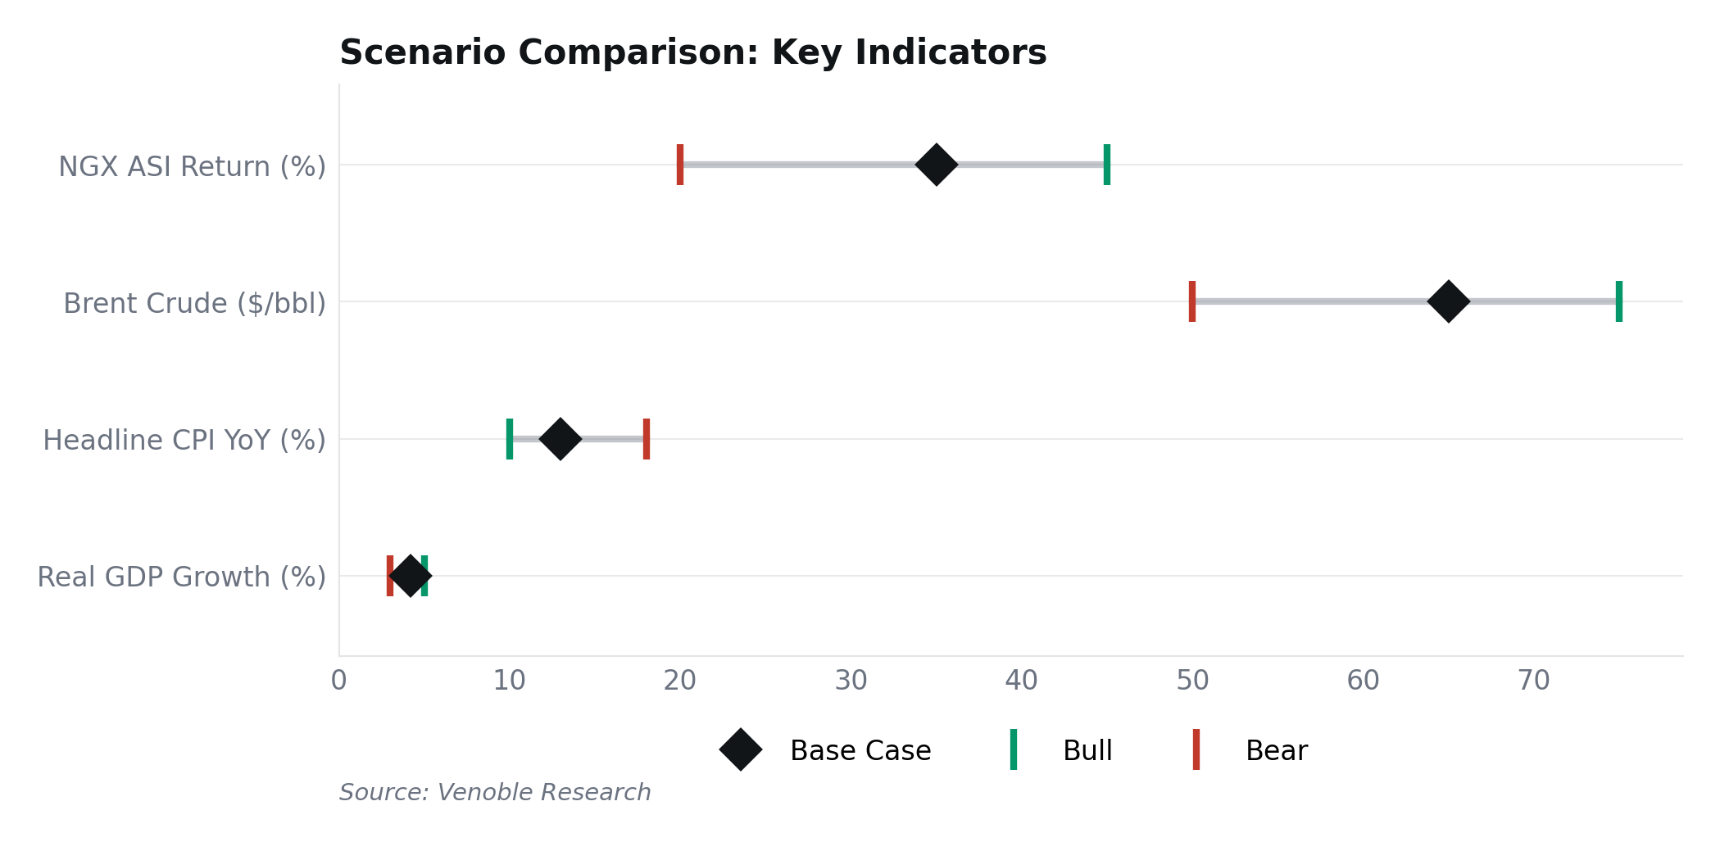
Source: Venoble Research

Risks to Watch
In the bear case (25% probability), Brent falls below $55 and the fiscal math breaks. Reserves drop, the Naira tests ₦1,700+, and the disinflation story reverses. Every Nigerian allocator should size against it.
Scenario | GDP | Inflation | MPR | ₦/USD | NGX Return
Bull | 5.0% | 10.0% | 22.0% | 1,400 | +45%
Base | 4.2% | 13.0% | 24.0% | 1,550 | +35%
Bear | 3.0% | 18.0% | 27.0% | 1,800 | −20%

PART I

Macroeconomic
Overview
Global context, GDP & growth, inflation, monetary policy, fiscal policy, and FX.

1. Global Economic Context

Global Growth & Monetary Policy
The IMF projects global growth at 3.3% for 2026, with EM economies expanding at 4.2%. We don’t spend time on these numbers. For Nigerian allocators, the global backdrop transmits through exactly two channels: the Fed funds rate (currently 3.50–3.75%) sets the opportunity cost for FPI capital, and Brent crude funds roughly half of Nigeria’s fiscal revenue. Everything else is noise.
The Fed held rates through H1 2026 and Goldman Sachs expects two additional cuts this year (June and September). That matters because FPI into Nigeria hit $12.99bn in the first nine months of 2025, with Q3 alone surging 439% YoY. Over 80% initially flowed into money market instruments, though that share fell to c.61% by Q3 as investors rotated into bonds. Lower US rates mean lower EM opportunity cost, which means more demand for NGN assets. Stanbic IBTC warned that external shocks could derail Nigeria’s outlook. We think the risk is real but containable if Brent holds above $60.

Commodity Prices: Oil and Fiscal Transmission
Brent opened 2026 near $61/bbl, climbing to $72 by late January. Iran-related geopolitical risk briefly spiked prices to $79 in early March. The EIA’s base case is $58/bbl on average for 2026, with a global supply surplus of 2.1–4.0 mb/d in H1. Goldman Sachs sees $64. We use $65 as our working assumption, which sits above the 2026 budget benchmark of $64.85.
The transmission chain is what matters. Brent feeds into FAAC allocations, which fund state governments and drive fiscal headroom. FAAC feeds into reserves ($50.45bn at last count), which backstop FX supply on NAFEM, which anchors Naira stability, which determines the pace of disinflation, which ultimately drives real returns on every Nigerian asset. At $75 Brent, the 2026 budget runs a manageable deficit. At $50, the entire chain unravels. Size your portfolio around that number.
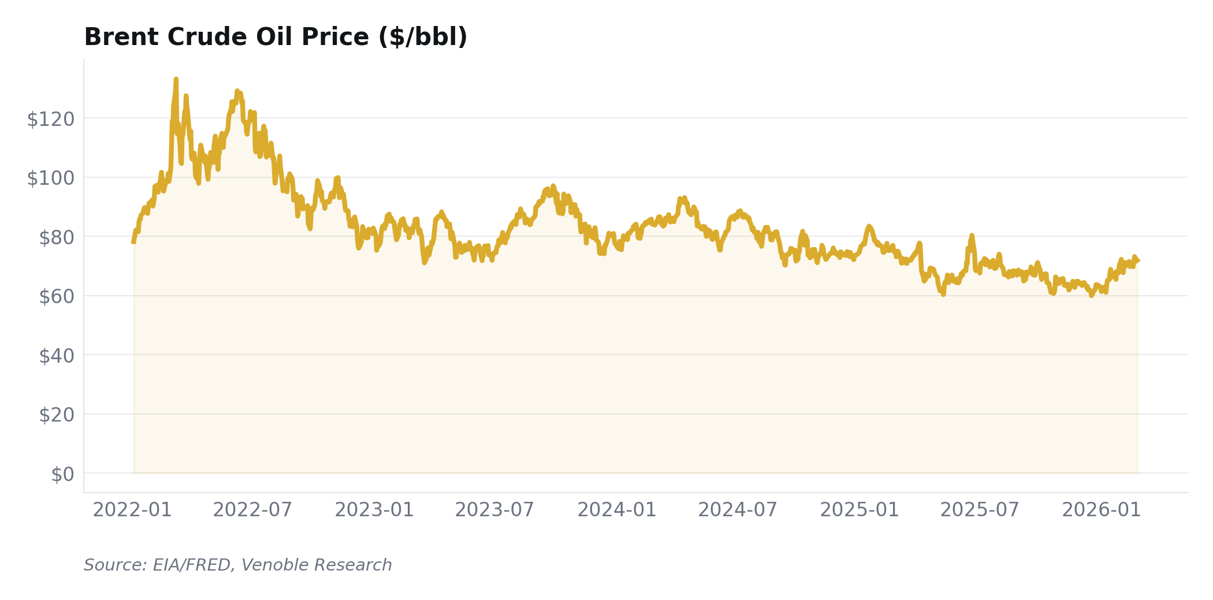
Source: EIA/FRED, Venoble Research

Implications for Nigeria
Our base case: Brent at $65, Fed holds at 3.50–3.75%, and moderate FPI inflows continue into NGN fixed income. This supports FX stability around ₦1,450–1,550, continued disinflation, and room for Cardoso to deliver another 200–300bp of cuts. The bear scenario (Brent below $55, global risk-off) would reverse all three. We assign 55% probability to the base case.
GLOBAL CONTEXT
Nigeria’s markets transmit through two channels: Brent crude (~50% of fiscal revenue) and US rates (FPI opportunity cost). Our base: Brent $65/bbl, Fed funds 3.50–3.75%. Both supportive.

Sources: IMF World Economic Outlook (Jan 2026); Federal Reserve FOMC (Jan 2026); EIA Short-Term Energy Outlook (Feb 2026); Goldman Sachs Global Investment Research; NBS Capital Importation Report Q3 2025; Stanbic IBTC 2026 Outlook.

2. Nigeria GDP & Growth Outlook

Real GDP Growth
Nigeria’s GDP growth has accelerated in every quarter since Q1 2023 (2.31%). Q4 2024 printed 3.84%. Q3 2025 came in at 3.98%, up from 2.54% two years earlier. The trajectory is clear, and the drivers are real: Naira float (Jun 2023) forced import substitution. Subsidy removal freed up fiscal space. Dangote Refinery reached full 650,000 bpd capacity in February 2026, a global single-train record.
Consensus for 2026 is tightly clustered: IMF at 4.4%, CBN at 4.49%, CardinalStone at 4.4%, PwC at 4.3%. We sit slightly below at 4.2%. Why? The government’s oil production target of 2.06 mbpd is unrealistic. Actual production averaged 1.64 mbpd in 2025, and the January 2026 figure was 1.478 mbpd. Closing that gap requires pipeline security and OPEC+ quota flexibility that we don’t see arriving this year. Cordros expects the economy to "gradually move beyond shock absorption," and we agree on direction but not on magnitude.
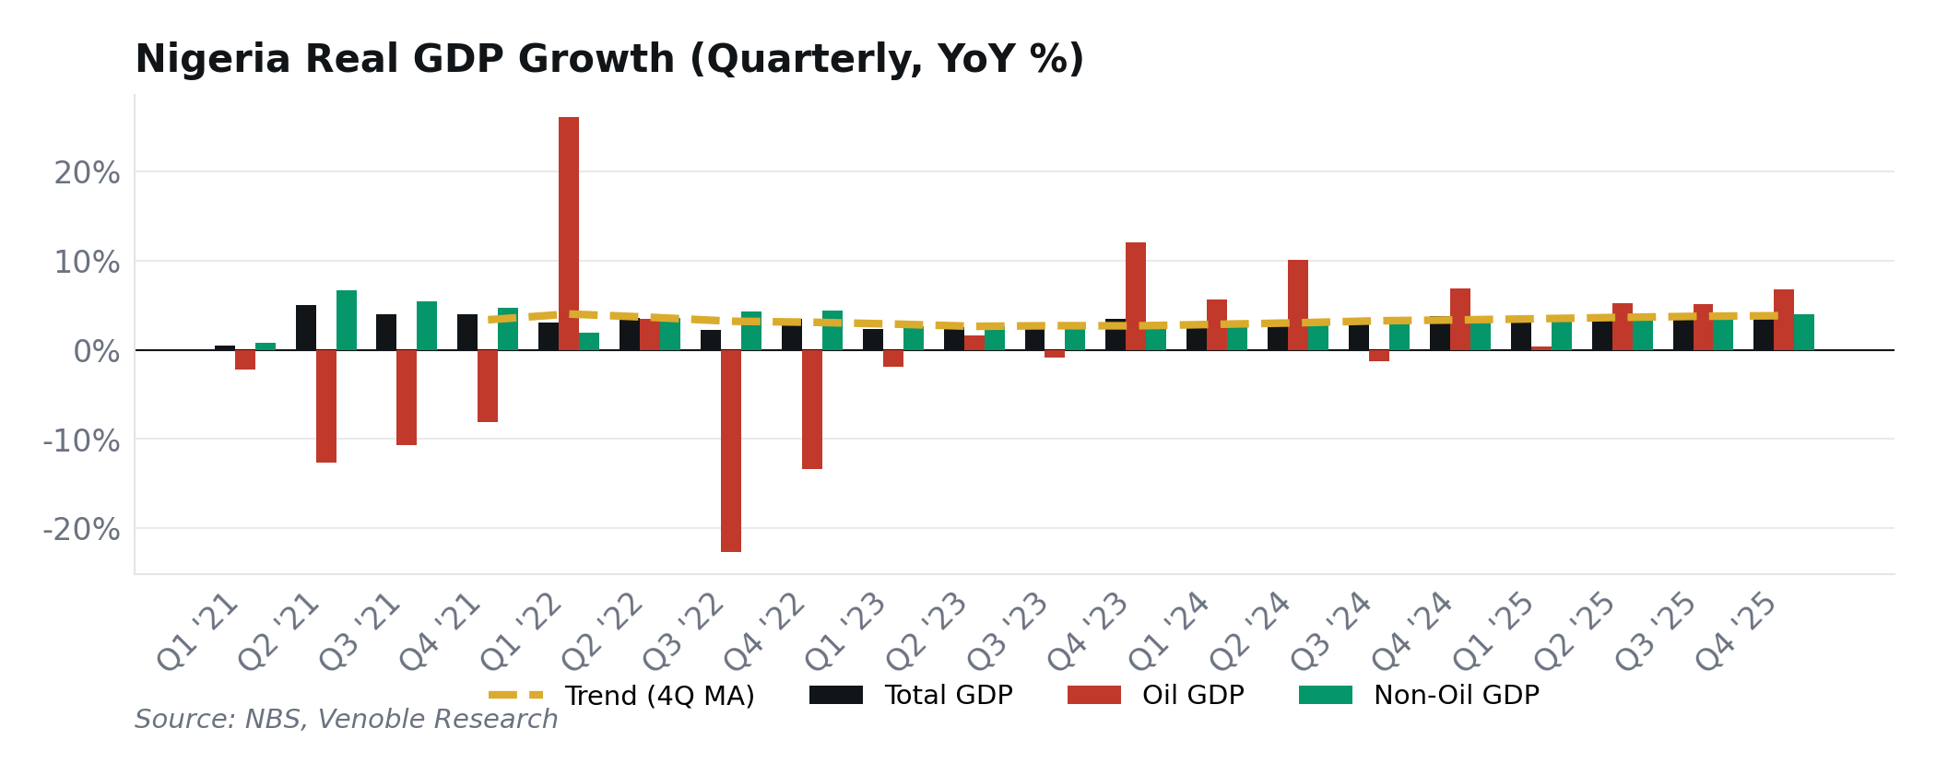
Source: NBS, Venoble Research

Oil vs Non-Oil GDP
Non-oil GDP is the real story. Services account for c.53–58% of output, and CardinalStone forecasts financial services growth of 20.3% for 2026. MTN Nigeria posted record revenue of ₦5.2 trillion, with data now 53% of the top line. Dangote’s refinery supplied 62% of domestic PMS in January 2026, significantly reducing annual FX outflows on refined product imports.
Oil GDP is volatile and policy-dependent. The OPEC+ quota stands at 1.5 mbpd. Abuja’s budget assumes 1.84 mbpd. We see 1.6–1.7 mbpd as more realistic, which means oil revenue will undershoot the budget by 10–15%. The investment opportunity is not in oil production. It is in the non-oil sectors that are quietly compounding regardless of what OPEC decides.

Sectoral Analysis
Agriculture grew 3.79% in Q3 2025 but remains constrained by insecurity in the food belt. Industry expanded 3.77%, boosted by Dangote’s capacity ramp and cement demand. Services, at c.53–58% of GDP, are the growth engine. Telecoms, fintech, and financial services are all growing above 10% YoY. We expect services to carry the economy in 2026 while agriculture benefits from a good harvest season (if the rains come on time in the northeast).
Sector | % of GDP | 2024 | 2025E | 2026F | Driver
Agriculture | 23% | 3.6% | 3.8% | 4.0% | Harvest, food prices
Industry | 20% | 3.5% | 3.8% | 4.5% | Dangote, cement
Services | 57% | 4.0% | 4.5% | 4.8% | Fintech, telecoms
Total GDP | 100% | 3.4% | 3.8% | 4.2%

Sources: NBS GDP Report Q3/Q4 2025; IMF World Economic Outlook (Jan 2026); CBN Communiqué (Feb 2026); CardinalStone 2026 Outlook; PwC Nigeria Economic Outlook 2026; Cordros 2026 Outlook; OPEC Monthly Oil Market Report (Feb 2026).

3. Inflation & Consumer Prices

Headline Inflation Trajectory
The disinflation is real. Headline CPI fell from 34.80% to 15.10% in thirteen months. And it changes the maths on every Nigerian asset.
Headline CPI peaked at 34.80% in December 2024 (old base) and fell to 15.10% by January 2026. Eight consecutive months of decline from April through November 2025, with December ticking up to 15.15% on a methodology revision before resuming the decline. Food inflation fell from 26.08% (January 2025, new base) to 8.89%, its first single-digit reading in over a decade. That is not a typo. Food CPI had not been below 10% since mid-2015.
The decomposition tells you what is structural and what is base effects. Food disinflation (down 17 percentage points) is driven by harvest season, Naira stability reducing import costs, and Dangote PMS supply easing transport costs. Core inflation (17.72%) is stickier, driven by services, rent, and lagged pass-through of prior Naira weakness. The gap between food and core is 9 percentage points. That gap matters because it tells you where further disinflation will come from (food) and where it won’t (core, without more rate cuts).
Here is the Venoble angle: with CPI at 15.1% and the 91-day T-bill at 15.80%, the real yield is +0.7%. Barely positive. Every basis point of further disinflation is a basis point of real return on your T-bill portfolio. That is why the inflation trajectory is not just a macro variable. It is the single most important input for cash returns.
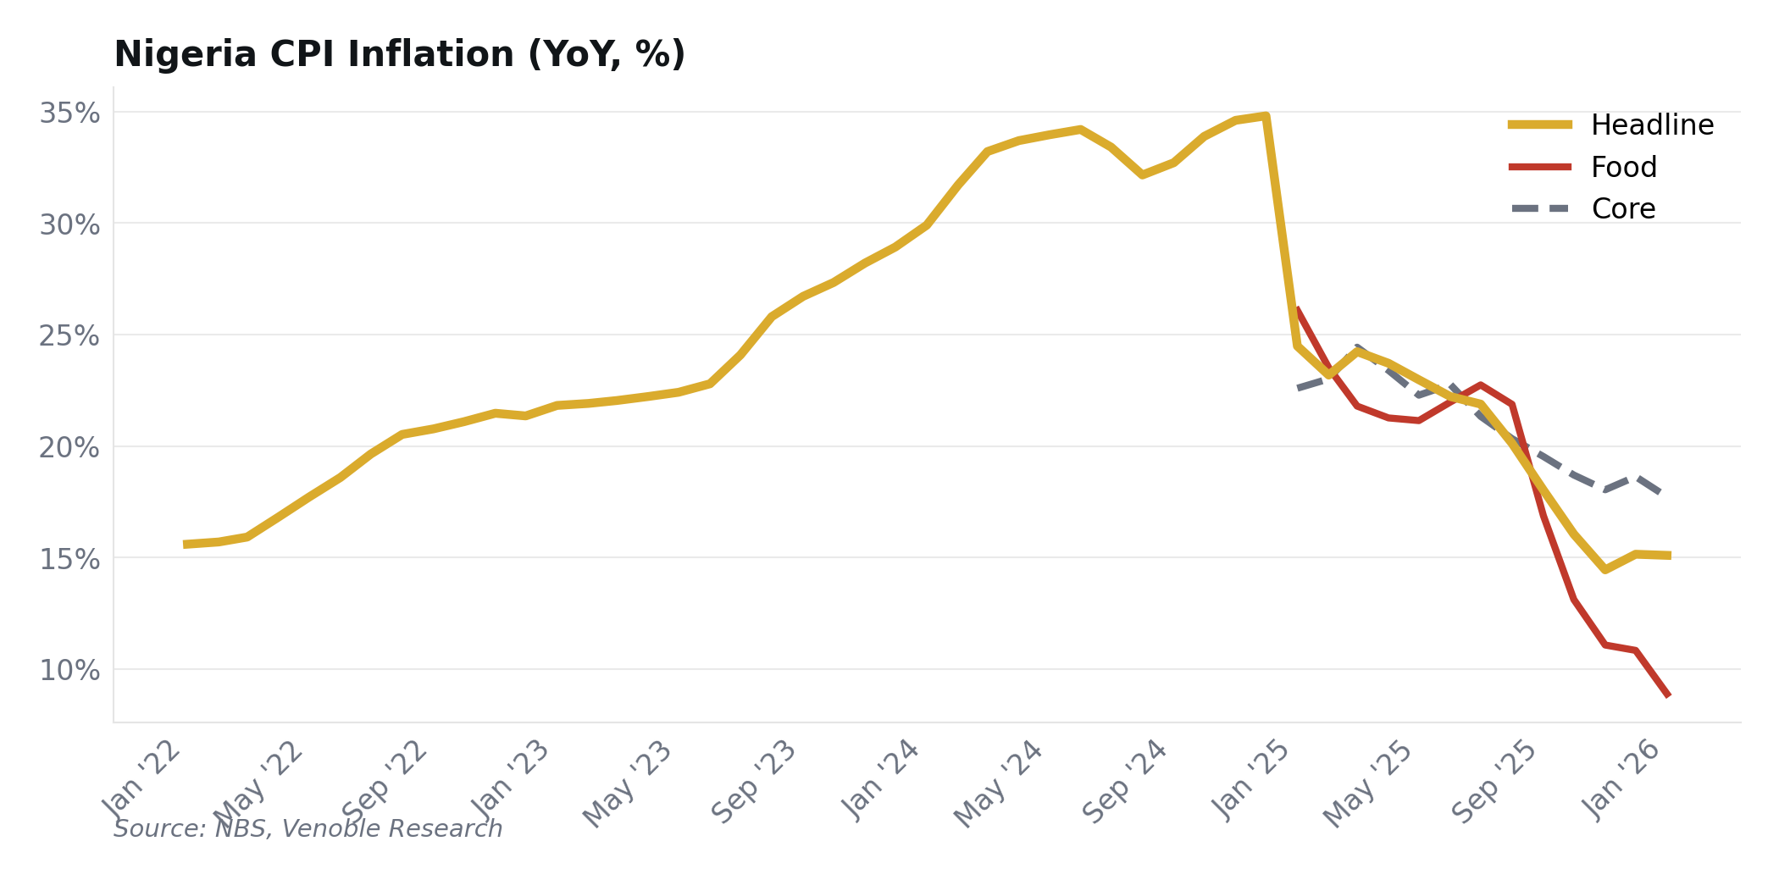
Source: NBS, Venoble Research

CPI Rebasing & Year-End Projections
NBS rebased the CPI effective January 2025 (new base: 2024 = 100), expanding the basket from 740 to 934 items. This makes direct YoY comparisons across the rebase discontinuous. Our VNG-CRR index uses a chain-linking factor of 0.11523 at the overlap month to maintain a continuous 17-year series. The methodology is transparent and documented at venoble.com.
Our year-end 2026 inflation forecast: 13% base case, 10% bull, 18% bear. The bull case requires a good harvest and Naira below ₦1,400. The bear case requires Brent below $55 and a disorderly Naira depreciation. CBN projects 12.94% on average for 2026. Cordros sees 14.70% year-end. CardinalStone is at 13.9%. We are in the middle of the pack, and frankly this is our lowest-conviction macro call. Food inflation is noisy and we can’t predict the rains.
METHODOLOGY NOTE
The VNG-CRR uses chain-linking across the Dec 2024 CPI rebasing (factor: 0.11523) to maintain a continuous 17-year series.

Sources: NBS Consumer Price Index Reports (Jan 2025 – Jan 2026); CBN MPC Communiqué (Feb 2026); Cordros Research; CardinalStone Research; Venoble VNG-CRR Pipeline.

4. CBN Monetary Policy

MPR Outlook & Liquidity Management
Cardoso hiked the MPR from 18.75% to 27.5% across six meetings in 2024, building on the tightening that began under his predecessor. Eight hundred and seventy-five basis points in twelve months. The most aggressive single-year cycle in CBN history. Then the pivot: 27.0% in September 2025, 26.5% in February 2026. Both cuts were 50bp. Both were unanimous. Cardoso called it "reflecting growing confidence in our disinflation process."
Our call: two to three more 50bp cuts in 2026, bringing the MPR to 24.0–25.0% by December. CardinalStone expects 300–400bp of total cuts this year. We think that is aggressive. Cordros is more cautious, and we are closer to Cordros. The condition for acceleration is clear: if headline CPI breaks below 13% and food inflation stays in single digits, Cardoso moves to 100bp clips. If food re-accelerates (bad harvest, Naira spike), he pauses. The next MPC meeting is May 19–20, 2026. We expect a hold.
The CRR remains at 45% for commercial banks and 16% for merchant banks. This is sterilising enormous liquidity from the system. When Cardoso eventually begins unwinding CRR (not in 2026, in our view), the liquidity impact on money markets will be substantial. That is a 2027 story.
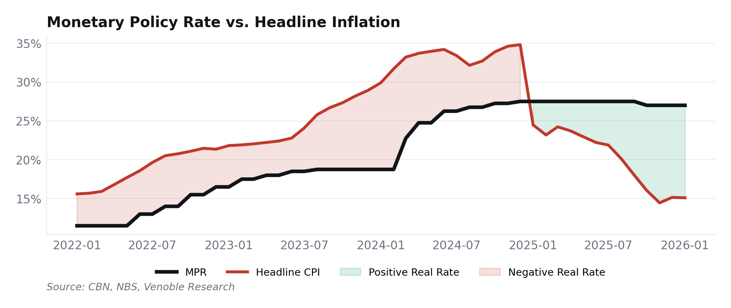
Source: CBN, NBS, Venoble Research

Real Interest Rate Analysis
MPR at 26.5% minus CPI at 15.1% gives a real policy rate of +11.4%. One of the highest in the world. This is not an accident. Cardoso is running an explicitly tight real rate to anchor disinflation expectations and attract foreign capital. The VNG-CRR confirms the real-world impact: cash instruments have delivered positive real returns for several consecutive months now, the first sustained positive period since mid-2019.
What does this mean for allocators? Cash is no longer dead money. It is a competitive asset class. Any equity or real estate investment must clear the real cash yield to justify its risk. The question is whether Cardoso cares more about crushing inflation to single digits or about supporting growth. We think inflation wins until H2 2026, then growth takes over. But February’s communiqué language was genuinely ambiguous on the balance of priorities.
VNG-CRR INSIGHT
For the first time since mid-2019, cash instruments deliver positive real returns. The real policy rate stands at +11.4%, the widest spread since the tightening cycle began.

Sources: CBN MPC Communiqués (all 2024–2026 meetings); CardinalStone 2026 Outlook; Cordros 2026 Outlook; CBN Statistical Bulletin.

5. Fiscal Policy & Government Finances

2026 Budget & Revenue Analysis
The revenue numbers speak for themselves. Non-oil taxes exceeded target by ₦3.4 trillion in 2025. The Nigeria Revenue Service (NRS, replacing FIRS) is targeting ₦40.7 trillion for 2026, up from ₦28.2 trillion collected in 2025. Tinubu signed the tax reform bills in June 2025, consolidating 60+ levies into fewer than 10 statutes. Tax-to-GDP is climbing toward c.10%. The shift matters more than the headline number.
Tinubu’s 2026 budget tells a different story. Total expenditure: ₦58.18 trillion. Revenue target: ₦34.33 trillion. Deficit: ₦23.85 trillion (4.28% of GDP). The budget assumes oil at $64.85/bbl and production at 1.84 mbpd. Oil is currently trading near $60. Actual January production was 1.478 mbpd. One of those assumptions is wrong. Probably both. Cordros flagged the oil production gap as the primary fiscal risk in their 2026 outlook, and we agree. CardinalStone is more sanguine on non-oil revenue offsetting the shortfall.
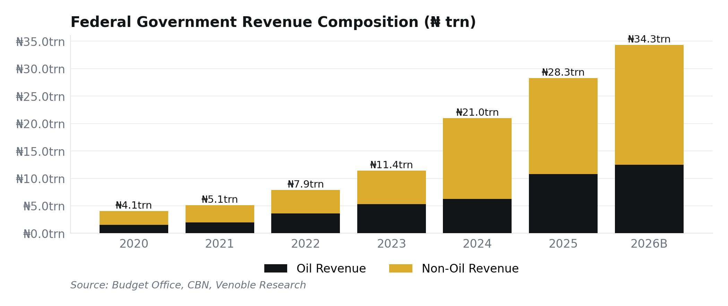
Source: Budget Office, CBN, Venoble Research

Debt Sustainability
Nigeria’s debt-to-GDP ratio of c.35% (Moody’s 2026 estimate) looks manageable by EM standards. That number is misleading. The real problem is debt service relative to revenue. In Q1 2025, total debt service consumed 113% of retained revenue. The IMF-World Bank DSA threshold for external debt service is 23% for strong-capacity countries, and even Nigeria’s external component alone exceeds it. The January 2026 Eurobond issuance ($2.25 billion, strong demand) shows market access remains intact. But access and sustainability are not the same thing. The 2027 election cycle will put upward pressure on spending from H2 2026. That is when fiscal discipline will be tested.
Indicator | 2023A | 2024A | 2025E | 2026F
Expenditure (₦T) | 21.8 | 29.0 | 35.1 | 58.2
Revenue (₦T) | ₦11.4 | ₦21.0 | ₦0.0 | ₦34.3
Deficit / GDP | 4.0% | 4.4% | 3.9% | 4.3%
Debt / GDP | 38% | 36% | 35% | ~35%

Sources: Budget Office of the Federation; DMO Debt Statistics (Q1 2025); IMF-World Bank Debt Sustainability Analysis; Moody’s Sovereign Rating Report; Cordros 2026 Outlook; CardinalStone 2026 Outlook.

6. Foreign Exchange & External Sector

NAFEM Rate Outlook
The Naira has been the surprise of 2025–2026. Cardoso’s FX unification policy, launched in June 2023, is finally delivering. From above ₦1,700/$ on the parallel market in early 2024 to ₦1,357/$ on NAFEM in February 2026, with a parallel premium of just ₦20–50, the narrowest gap since the float. FMDQ daily FX turnover rose from $150 million (2021) to $430 million (2025). The market is deeper, more liquid, and more transparent than at any point in memory.
Our year-end range: ₦1,450–1,550 base case, ₦1,350–1,400 bull, ₦1,700–1,800 bear. Cordros sees ₦1,350. CardinalStone sees ₦1,350–1,450. Afrinvest is at ₦1,431. We are deliberately wider than consensus because the Naira’s current strength is oil-funded, not structurally earned. If Brent drops below $55 for a sustained period, reserves deplete, FX supply dries up, and the parallel market reopens. That is not our base case but it deserves a wider range than the street is pricing.
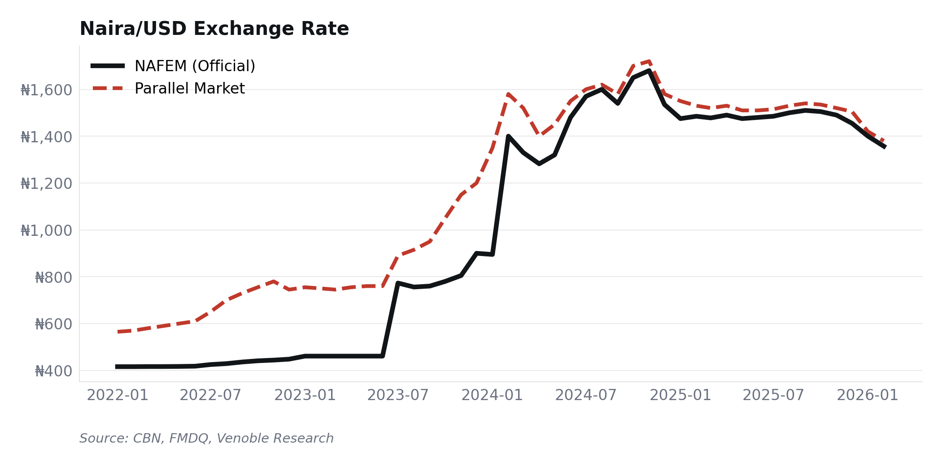
Source: CBN, FMDQ, Venoble Research

External Reserves & Capital Flows
Reserves hit $50.45 billion in February 2026. Thirteen-year high. The build-up came from multiple sources: record remittances estimated at $25 billion in 2025 (up from $19.5 billion in 2023 per World Bank data), a $2.25 billion Eurobond issuance in January, and continued FPI inflows attracted by high yields. Import cover stands at 9.68 months. CBN spent $7.8 billion on FX management in 2025 (per Stanbic IBTC), and still reserves grew.
Remittances are replacing oil as the FX driver. Over 70% of diaspora flows originate from the US, UK, and Canada. Afrinvest revised full-year 2025 capital importation upward to $23.3 billion, which would mark the strongest annual figure in six years. But here is the composition problem: FPI accounts for 80%+ of capital flows, and only 3.3% is FDI. Short-term, yield-chasing money. If real yields compress faster than expected, the flows reverse.
For international investors, the carry is real. NGN fixed income yielding 15–18% against a broadly stable currency. The NGX returned approximately +61% in USD terms in 2025, boosted by Naira appreciation. But position sizing should reflect the 20–30% annualised NAFEM volatility.
Indicator | 2023A | 2024A | 2025E | 2026F
₦/USD (NAFEM, Y/E) | 900 | 1,535 | 1,455 | 1,550
Reserves ($bn) | 33.2 | 40.9 | 45.5 | 48–52
Import Cover (mo) | 5.1 | 6.5 | 8.5 | 9.7
Remittances ($bn) | 19.5 | 21.9 | 25.0 | ~26

Sources: CBN/FMDQ Exchange Rate Data (Feb 2026); CBN External Reserves Statistics; World Bank Migration & Remittances Data 2025; NBS Capital Importation Q3 2025; Afrinvest 2026 Outlook; Stanbic IBTC Research; Cordros 2026 Outlook; CardinalStone 2026 Outlook.

PART II

Capital Markets
Outlook
Fixed income, equities, and the VNG-CRR real return analysis.

7. Fixed Income Markets

Treasury Bills & FGN Bonds
This is the trade. The February 18 NTB auction told the story: ₦4.28 trillion in subscriptions against ₦1.15 trillion offered. Bid-to-cover of 3.7x. The 364-day stop rate fell to 15.90%, dropping below 16% for the first time. Six weeks earlier, the same tenor cleared at 18.47% (January 7). That is 257bp of compression. The market is all-in on duration.
FGN bonds tell the same story. The January DMO auction attracted ₦2.25 trillion in subscriptions against ₦900 billion offered (2.5x). The 10-year closed at 16.55% in late February. The curve is normalising from its deeply inverted shape as short rates fall faster than long rates. The February MPC cut accelerated this trend.
Our duration call: the 5–10Y belly offers the best risk-adjusted returns. Short-end T-bills (15–16% carry) are fine for cash management, but the capital gains opportunity is in the belly. Cordros sees NTB yields at 12.5% and bond yields at 12.9% by year-end. We think 12.5% NTB is aggressive. We see 13–14% for the 91-day and 14–15% for the 10-year by December. The long end (20Y+) carries 2027 election political risk that we don’t want to own yet.
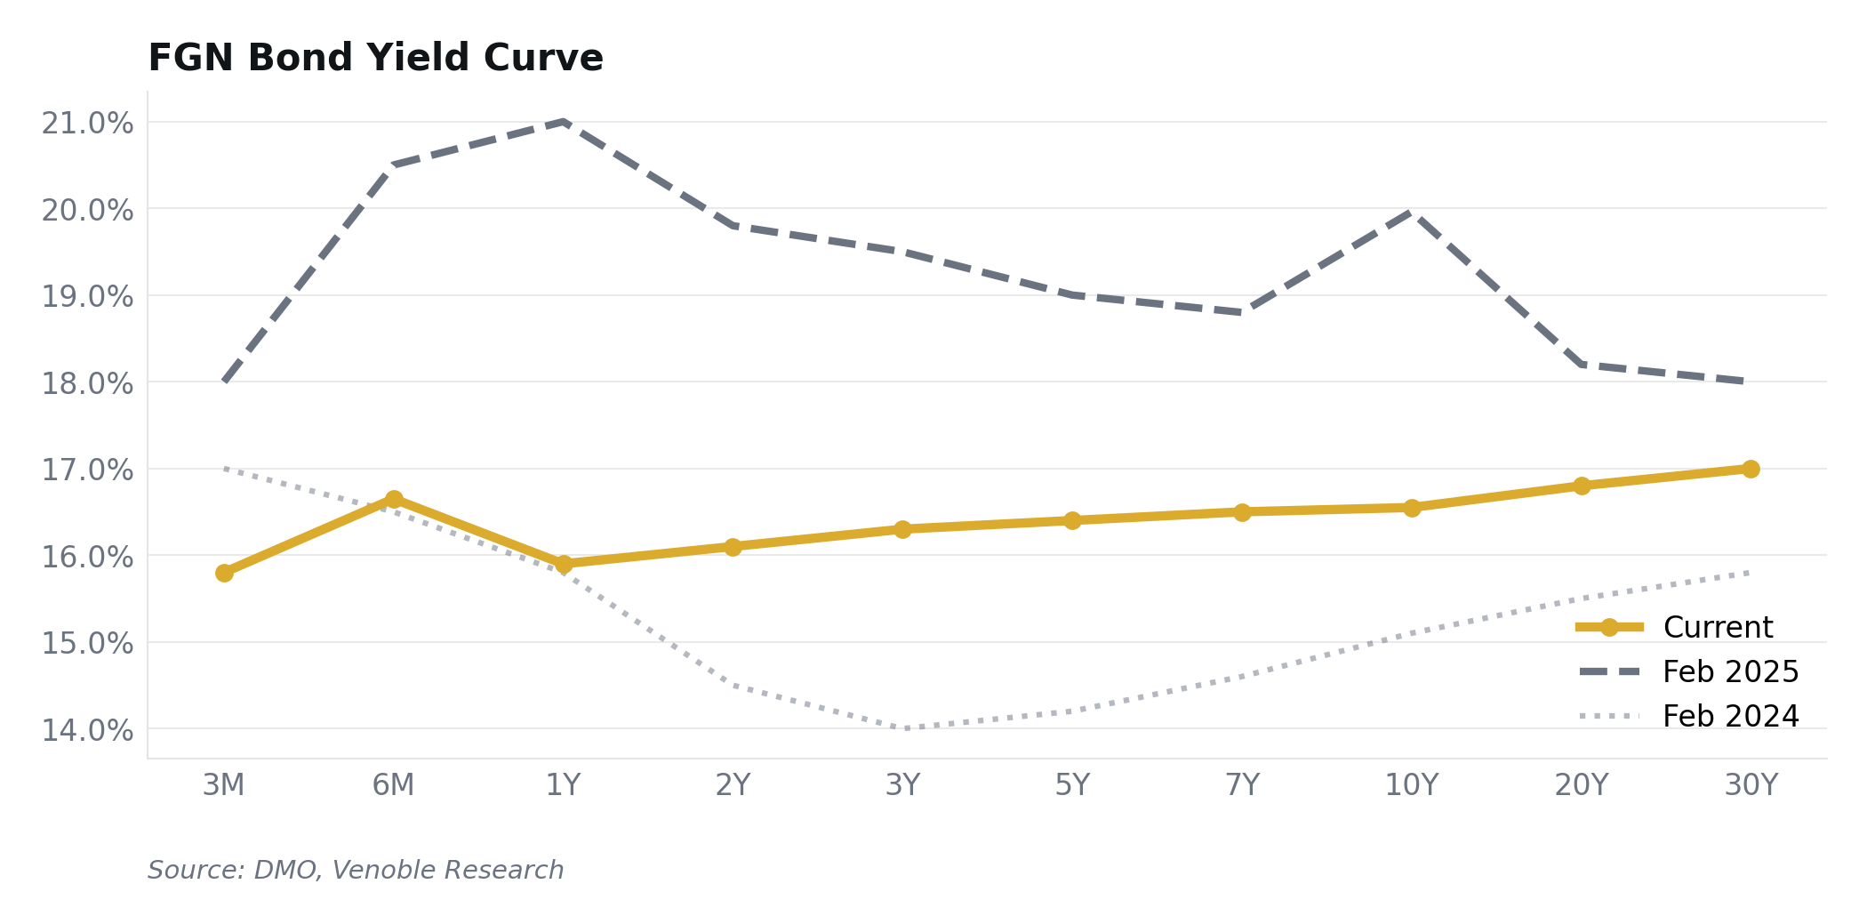
Source: DMO, Venoble Research

Real Yield Analysis
The 91-day real yield (T-bill rate minus CPI) is approximately +0.7%. Thin, but positive. Move further out the curve and the real yield picture improves: the 5-year FGN bond at c.16.4% delivers a real yield of roughly +2% against current inflation. The 10-year at 16.55% gives +1.5%. Real yields turn negative only if you believe inflation re-accelerates above 17%, which requires a bear scenario on oil and FX.
This is analysis nobody else publishes for Nigeria. Cordros, CardinalStone, and Afrinvest all publish nominal yield forecasts. None of them frame the duration decision through a real yield lens. That is what the VNG-CRR makes possible: a continuous, real-time measure of whether your fixed income allocation is actually earning or losing ground to inflation.
FIXED INCOME VIEW
Overweight Nigerian fixed income for 2026. Preference for 5–10Y FGN bonds as the easing cycle compresses yields. VNG-CRR real yields positive, supporting cash-plus strategy.

Sources: CBN NTB Auction Results (Jan–Feb 2026); DMO Bond Auction Results (Jan 2026); FMDQ Secondary Market Yield Data (Feb 2026); Cordros Research.

8. Equities Market

NGX All-Share Performance & Valuations
The NGX has been extraordinary. +37.65% in 2024. +51.19% in 2025. ~25% YTD through February 2026, with the ASI surpassing 194,000. Market capitalisation exceeded ₦125 trillion. In USD terms, the NGX delivered approximately +61% in 2025, boosted by the Naira’s appreciation.
What drove it? Bank recapitalisation. Twenty of 33 banks met the CBN’s March 31, 2026 deadline, raising over ₦4 trillion in fresh capital through rights issues and public offers. Insurance companies are on their own recap wave. PenCom raised equity allocation limits (Fund I: 30% to 35%, Fund II: 25% to 33%), potentially unlocking ₦1.6 trillion in new demand. Pension assets now total ₦26 trillion, with equity allocation up from ₦908 billion in 2022 to ₦3.96 trillion in 2025.
But the PMI printed 49.7 in January 2026, the first sub-50 January reading on record (it recovered to 53.2 in February). Consumer goods index rallied 129.6% in 2025, yet margin compression persists. We forecast 30–40% NGX total return for 2026 (base case 35%), below the sell-side consensus of 40%+. Our relative caution reflects three headwinds the consensus underweights: bank EPS dilution from recapitalisation share issuance (ROE normalising from 25% to 20–23%), the onset of election-cycle uncertainty from Q3, and the mathematical reality that three consecutive years of 35%+ returns has no precedent in NGX history. The easy beta trade is done. 2026 is a stock-picker’s market.
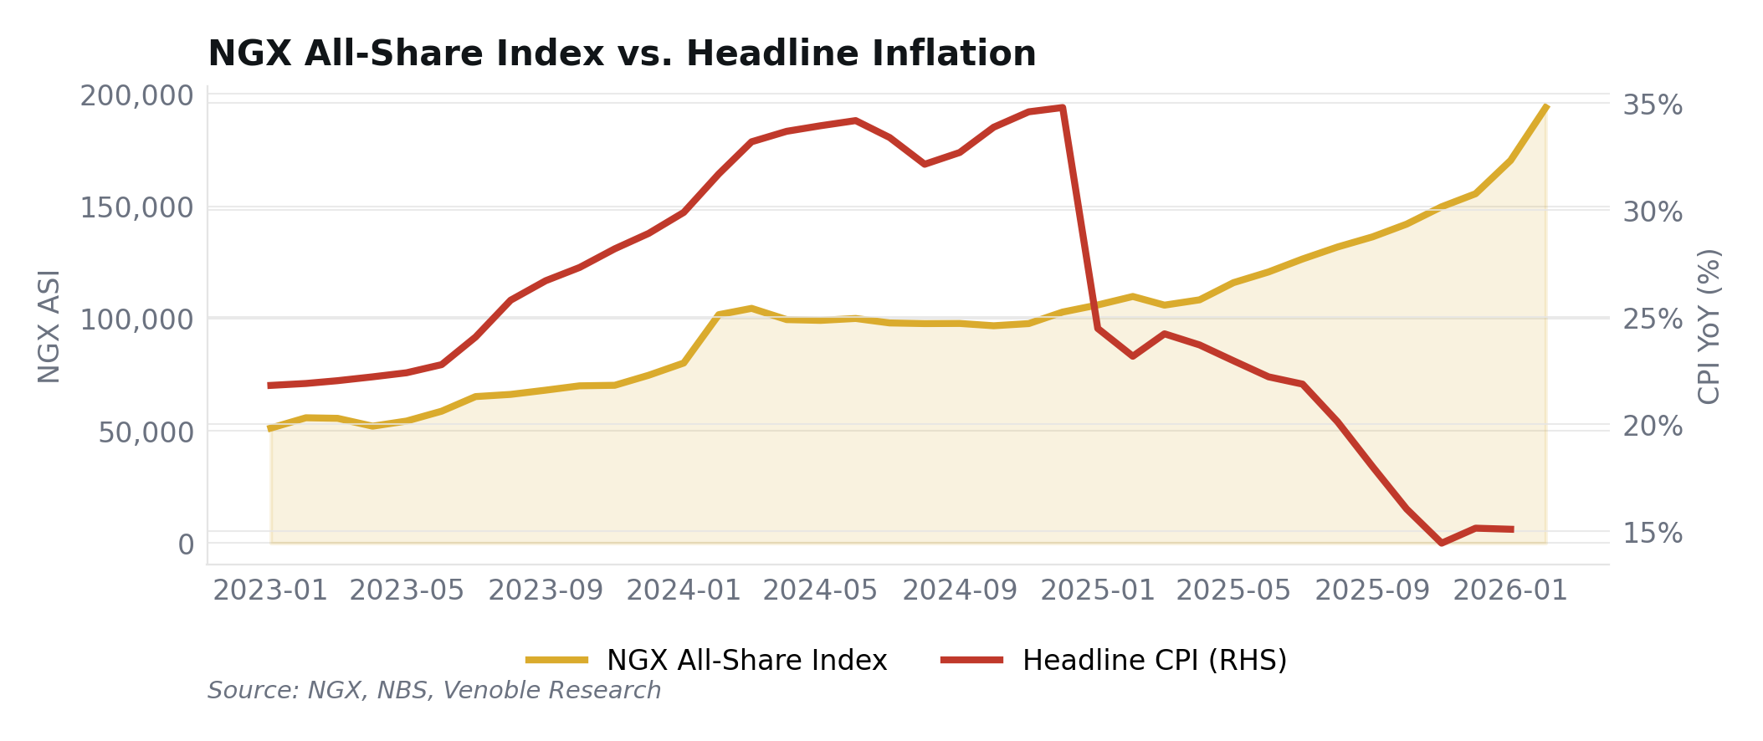
Source: NGX, NBS, Venoble Research

Foreign Portfolio Investment
FPI hit $12.99 billion in the first nine months of 2025, with Q3 surging 439% YoY. In Q3 2025, the UK accounted for 48.8% of portfolio flows, the US 15.8%, South Africa 12.9%. Afrinvest revised full-year estimates to $23.3 billion. But the composition is telling: 80%+ went into money market instruments, not equities. Foreign investors are buying Nigerian yield, not Nigerian earnings. The first net positive foreign equity flow in three years showed up in late 2025, but it was modest.
What brings more equity FPI? Three conditions: sustained FX stability (check), positive real rates (check), and corporate governance improvements (work in progress). The Dangote Refinery IPO, expected within five months, could be the trigger that pulls foreign equity capital off the sidelines. If it lists, it would be the largest IPO in Nigerian history.

Sector Strategy & Key Picks
We favour banking (overweight), insurance (overweight), and industrials (overweight). We are underweight consumer staples. Banking is the recap trade: Tier-1 banks are raising capital at 2–3x book value, and Cordros expects sector EPS growth of 19.1%. Insurance is the next recap re-rating. Industrials benefit from Dangote-driven import substitution. Consumer goods face margin compression from input costs that have not fully normalised despite Naira stability.
Ticker | Company | Sector | Mkt Cap | P/E | Yield | View
GTCO | GT Holding Co. | Banking | ₦4.3T | 6.1x | 6.9% | Overweight
ZENITH | Zenith Bank | Banking | ₦3.7T | 3.6x | 5.8% | Overweight
DANGCEM | Dangote Cement | Industrials | ₦13.1T | 13.0x | 3.9% | Overweight
MTNN | MTN Nigeria | Telecoms | ₦15.9T | 14.3x | 4.0% | Overweight

Market data as of March 2, 2026. Source: NGX, StockAnalysis.com. P/E = trailing twelve months.

Sectors to Watch
Each sector below gets our view, the driver, and the risk. We are specific because vague sector calls are worthless.
• Banking: Recap complete for 20 of 33 banks. 13 non-compliant face forced mergers by March 31. Watch Tier-2 M&A activity. Overweight.
• Oil & Gas: Dangote at 650,000 bpd is reducing refined product imports. PIA implementation is progressing. Sector returned −2% in 2025 as upstream stocks lagged. Hold for structural FX tailwind.
• Telecoms & Tech: MTN posted ₦5.2tn revenue (data 53% of total). NCC-approved 35% tariff hike (initially proposed at 50%, reduced after labour pushback) boosts ARPU but adds to inflation. 5G penetration below 3%. Overweight MTN on data monetisation.
• Consumer Goods: Index rallied 130% in 2025 on pricing power recovery. But input cost pass-through lags and margins remain compressed. New progressive CGT (up to 25% for individuals) on equity disposals above N10m is a headwind. Underweight.

Sources: NGX Group Market Data; CBN Banking Supervision Reports (Feb 2026); PenCom Industry Report (Dec 2025); NBS Capital Importation Q3 2025; Nairametrics; BusinessDay; Cordros Securities; StockAnalysis.com (equity fundamentals as of Mar 2, 2026); Afrinvest 2026 Outlook.

9. The VNG-CRR Index: Real Return Analysis
The Venoble Nigeria Cash Real Return Index (VNG-CRR) measures the real, inflation-adjusted return from holding Nigerian cash. 91-day T-bill yield minus CPI inflation, compounded monthly. Seventeen-year continuous history from February 2009 to present. This is uniquely ours, and no other Nigerian research house publishes an equivalent.

Index Performance Update
As of January 2026, the VNG-CRR nominal index stands at 1,182 (base 1,000 = January 2025). The real index is at 1,027. Translation: ₦1,000 invested in rolling 91-day T-bills at inception is now worth ₦1,182 in nominal terms but ₦1,027 after adjusting for inflation. Cash is beating inflation. Not by much, but it is beating it.
The monthly real yield has been positive for several consecutive months running. That is the first sustained positive stretch since mid-2019. The annualised nominal return over the full 17-year backtest is +9.48%. The annualised real return is −5.48%. Read that again. Cash holders lost roughly 5.5% of purchasing power per year for 17 years.
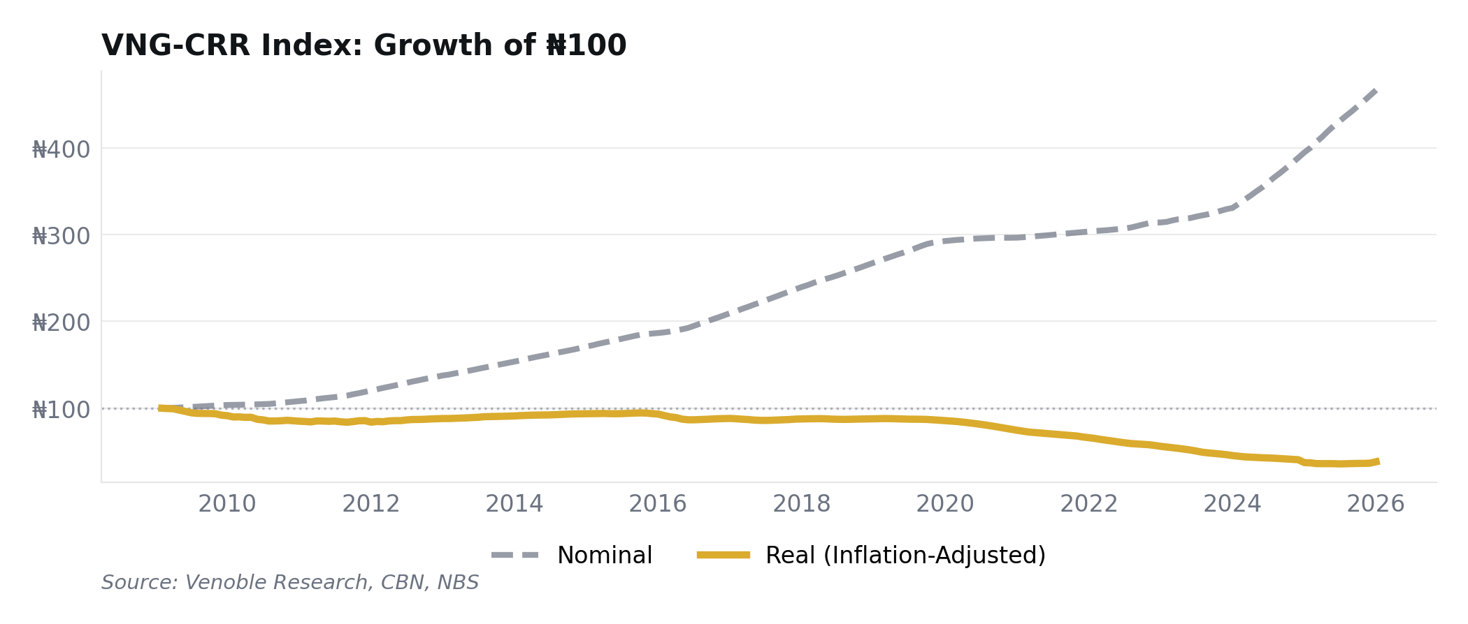
Source: Venoble Research, CBN, NBS

Historical Insights
The heatmap below shows the regime changes. Long stretches of red (2010–2015, 2020–2024) where inflation ate through nominal yields. Brief green patches (2017, early 2019) where tightening cycles created temporary real returns. And now, from mid-2025 onwards, a growing block of green as the current tightening cycle pushes real rates decisively positive.
The regime change is historically significant. Nigeria last sustained positive real cash rates in 2017–2018, during the post-recession tightening. The NGX rallied 42% in 2017. Bond yields compressed over 400bp. The precedent is clear: tight real rates attract capital, capital compresses yields, yield compression lifts asset prices.
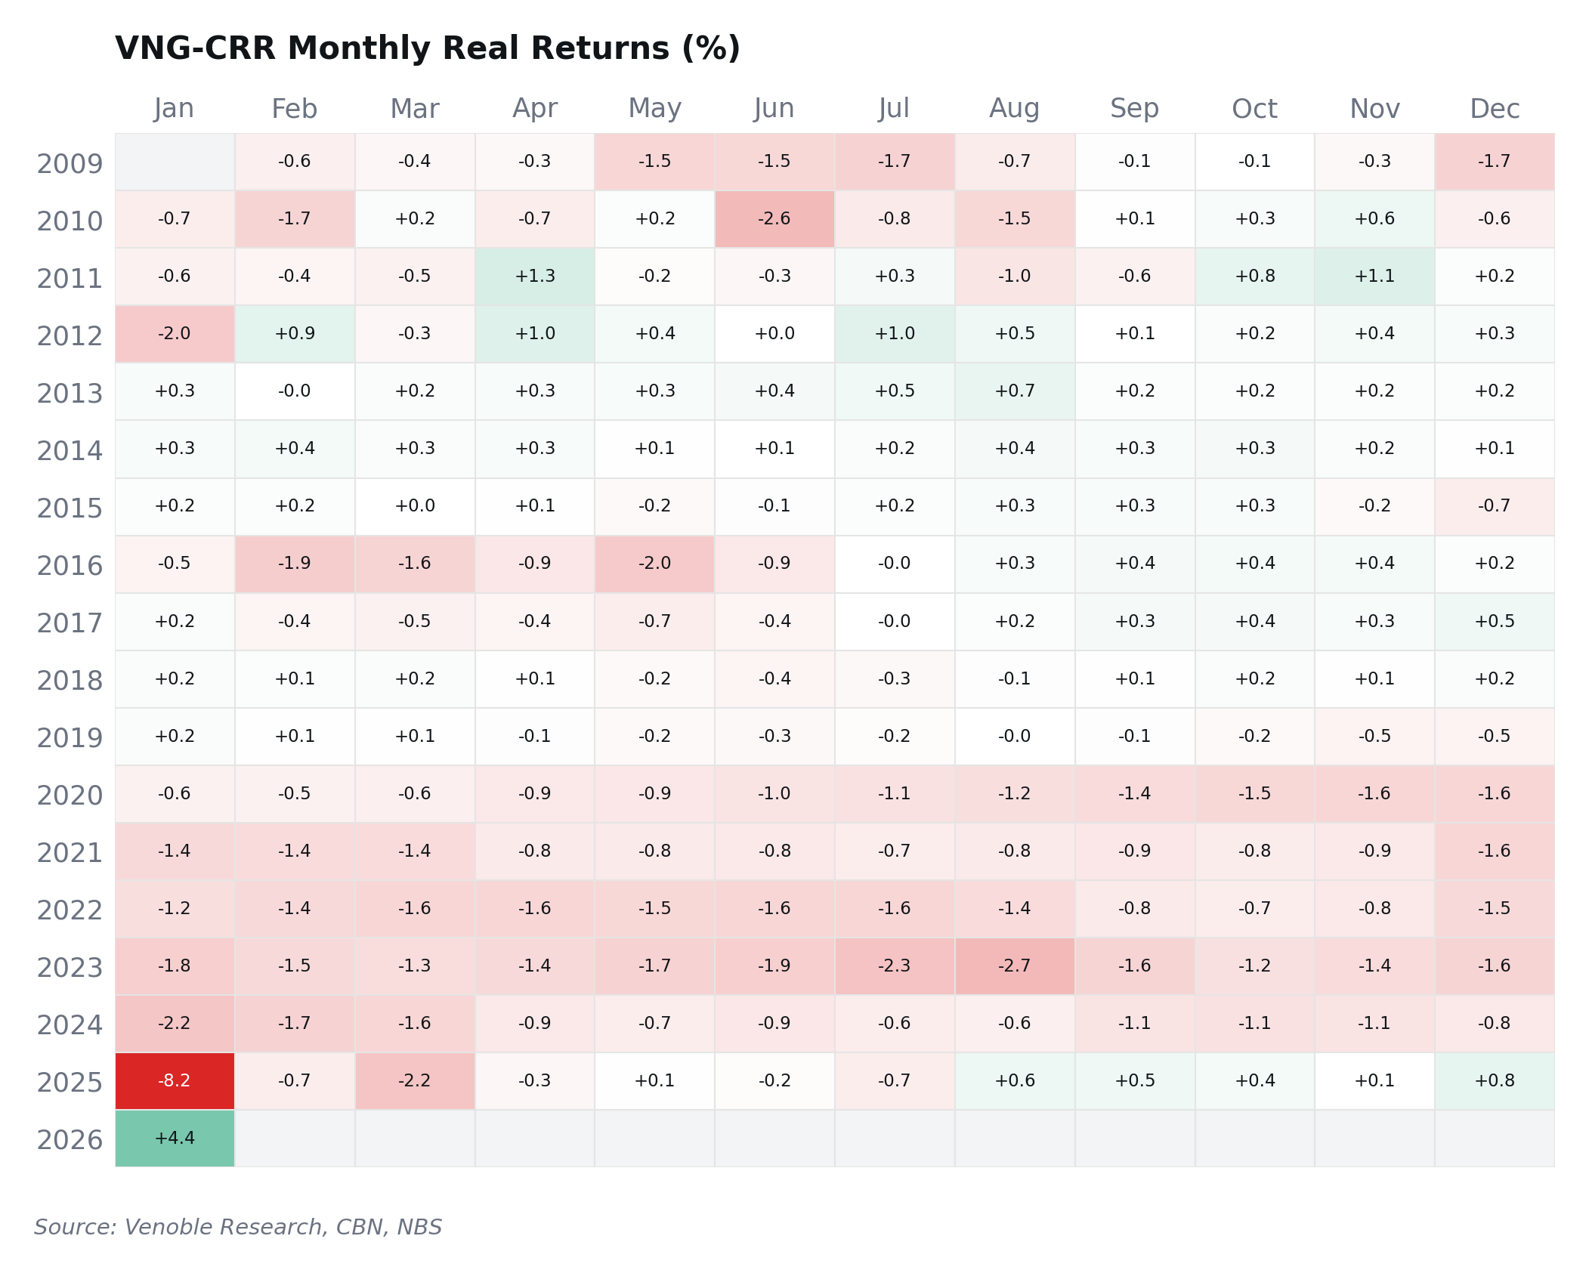
Source: Venoble Research, CBN, NBS

Implications for Allocators
The VNG-CRR creates a hurdle rate framework for every Nigerian asset. The nominal T-bill yield is c.15.8%. CPI is 15.1%. Real yield: +0.7%. Thin. But positive. Any equity or alternative investment must clear this hurdle to justify its risk. If equities can’t beat risk-free cash in real terms, why take the risk?
This is the allocator question for 2026. In an environment where cash earns positive real returns for the first time in years, the bar for risk-taking is higher. We think selected equities (banking recap, Dangote industrials) and duration-extended FGN bonds can clear the hurdle. But passive cash is no longer the penalty it was in 2021–2024 when the VNG-CRR was printing deep red every month.
INDEX NOTE
The VNG-CRR is the only continuous, publicly available benchmark for real returns on Nigerian cash. IOSCO-aligned methodology. Full data at venoble.com.

Sources: Venoble Research VNG-CRR Pipeline (204-month backtest, Feb 2009 – Jan 2026); CBN 91-day T-bill Auction Results; NBS Consumer Price Index Reports; Methodology: venoble.com/methodology.

PART III

Risk Assessment &
Portfolio Positioning
Scenario analysis, risk factors, asset allocation, and strategy recommendations.

10. Risk Assessment & Scenario Analysis

Scenario Framework
We assign 20% probability to the bull case, 55% to the base, and 25% to the bear. The bull requires Brent above $70, accelerated easing (300bp+), and sustained FPI inflows. The base assumes Brent at $65, 200–300bp of cuts, and gradual disinflation to 13%. The bear requires Brent below $55 for two or more quarters, policy reversal on FX or subsidies, and capital outflows. We are slightly more bearish than the street because the oil supply surplus (2–4 mb/d per EIA) creates genuine downside risk to Brent.
Variable | Bull (20%) | Base (55%) | Bear (25%)
Real GDP | 5.0% | 4.2% | 3.0%
Year-End CPI | 10.0% | 13.0% | 18.0%
MPR (Y/E) | 22.0% | 24.0% | 27.0%
₦/USD | ₦1,400 | ₦1,550 | ₦1,800
Brent ($/bbl) | $75 | $65 | $50
NGX Return | +45% | +35% | −20%
VNG-CRR Real | +2.5% | +0.7% | −3.0%

Key Risk Factors
• Oil Price Shock (30% prob.): Brent below $55 for two quarters collapses FAAC, drains reserves, forces Naira devaluation. EIA forecasts $58 average with 2–4 mb/d surplus. This is our highest-impact risk. What we would do: cut equity exposure to 10%, extend FGN bond duration (flight-to-domestic-quality), increase offshore to 20%.
• 2027 Election Fiscal Loosening (70% prob.): Pre-election spending historically begins 12–18 months before polls. From H2 2026, expect supplementary budgets, accelerated infrastructure contracts, and political appointments. Moderate impact: fiscal slippage raises debt issuance but does not derail the disinflation trajectory alone. What we would do: position for higher bond supply (belly may cheapen temporarily).
• Bank Recap Fallout (40% prob.): Thirteen banks missed the March 31 deadline. CBN signals forced mergers. Impact is contained because the 20 compliant banks hold 80%+ of system assets. But smaller bank depositors may panic. What we would do: stay in Tier-1 names only, avoid Tier-2 and merchant banks.
• Global Risk-Off (25% prob.): US recession or tariff escalation triggers EM capital outflows. FPI reverses. NAFEM comes under pressure. Trump’s 15% reciprocal tariff on Nigeria has limited direct trade impact (US = 7% of exports) but indirect oil price decline matters more. What we would do: raise cash allocation, reduce duration exposure.
• Security and Food Supply (35% prob.): Bandits and insurgents killed 2,266+ people in H1 2025. Farming disruption in the food belt could reverse food disinflation. If the rains come late in the northeast, food CPI re-accelerates and the CBN pauses easing. What we would do: monitor food CPI monthly, cut FI duration if food inflation exceeds 12%.
For context, Stanbic IBTC identifies external shocks and capital flow reversal as the primary risks to their constructive outlook. Cordros weights oil price risk highest, consistent with our framework. The consensus underweights election-cycle fiscal risk, which we think is a mistake.
Sources: EIA Short-Term Energy Outlook (Feb 2026); CBN MPC Communiqué (Feb 2026); ACLED Conflict Data H1 2025; Stanbic IBTC 2026 Outlook; Cordros 2026 Outlook; Venoble Research scenario analysis.

11. Portfolio Positioning & Implications

Asset Allocation Framework
The numbers tell you what to do. With the MPR at 26.5% against headline CPI of 15.1% (January 2026), the real policy rate stands at +11.4%, the widest positive spread since the tightening cycle began. This anchors our base-case asset allocation. The VNG-CRR real cash return is the hurdle rate every asset class must clear.
Fixed income dominates our base case (40%). The easing cycle, signalled by the February 2026 50bp cut to 26.5%, creates a duration opportunity in FGN bonds. We favour the 5–10Y belly of the curve where yields have compressed from 22%+ to 16–18%, with further gains likely as the CBN delivers 200–300bp of cuts through 2026. Short-duration T-bills and money market instruments (10%) provide carry at 15–16% with minimal duration risk.
Equities receive a moderate 25% base allocation. The NGX rally (+51% in 2025, +38% in 2024) is supported by the bank recapitalisation programme, a lasting tailwind as Tier-1 banks raise ₦4+ trillion in fresh equity. We are selective: overweight banking and industrial sectors, underweight consumer staples where margin compression persists.
Alternatives (15% base) include UPDC REIT, AFRILAND Properties, and infrastructure exposure via private credit funds. These provide inflation protection and diversification away from the rates cycle.
The 10% offshore allocation serves as an FX hedge. USD money market funds, EM bond ETFs, and S&P 500 exposure via SEC-registered vehicles are the three instruments. With the Naira at ₦1,357/$, we see the currency as fairly valued near term, but structural vulnerabilities (oil dependence, low non-oil exports) warrant maintaining dollar exposure.
Asset Class | Bull | Base | Bear | Rationale
FGN Bonds 5Y–10Y | 15% | 25% | 40% | Duration play on easing cycle
T-Bills / Money Mkt | 15% | 15% | 15% | 15–16% carry, positive real yield
Equities | 45% | 25% | 10% | Bank recap, selective sectors
Alternatives | 10% | 15% | 5% | Real assets, infrastructure
Offshore / FX Hedge | 5% | 10% | 15% | Currency diversification, FX hedge
Cash Reserve | 10% | 10% | 15% | Liquidity buffer
Total | 100% | 100% | 100%

Fixed Income & Equities Strategy
In fixed income, we position for 200–300bp of rate cuts by extending duration into the 5–10Y FGN bond segment. The yield curve has already begun to normalise from its deeply inverted shape, and we expect further steepening as short rates decline faster than long rates. In equities, we favour Tier-1 banks (GTCO, Zenith) trading at 2–3x book value with recapitalisation tailwinds, and industrial names (Dangote Cement) benefiting from import substitution. We are underweight consumer goods where input cost pressures persist. For comparison, Cordros allocates 35% to FI and 30% to equities in their base case. CardinalStone is more equity-heavy at 35%. Our higher FI allocation reflects our view that the easing cycle offers a cleaner risk-reward than a three-year-old equity rally.

FX Risk Management
For domestic investors, the 10% offshore allocation hedges against renewed Naira weakness. Instruments include USD money market funds for capital preservation, EM bond ETFs for yield diversification, and S&P 500 exposure via SEC-registered vehicles for long-term growth. Reserves at $50.45 billion provide a buffer, but the FX market remains sensitive to oil price shocks and capital flow reversals.
For international investors, the carry math works. NGN fixed income yielding 15–18% against a broadly stable currency. But position sizing should reflect the 20–30% annualised volatility in the NAFEM rate. Size modestly. Scale in on weakness.
ALLOCATION INSIGHT
Our VNG-CRR framework shows cash now delivers positive real returns for the first time since 2019. Any risky Nigerian asset must clear this hurdle. If it cannot beat risk-free cash in real terms, it does not justify the risk.

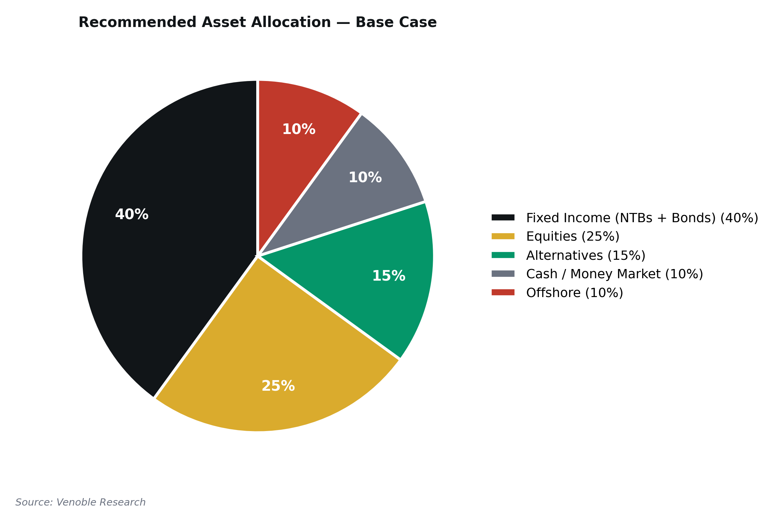
Source: Venoble Research
Sources: All preceding sections; Cordros 2026 Outlook (allocation comparison); CardinalStone 2026 Outlook (allocation comparison); Venoble Research.

Forecast Summary Table
Key Nigerian macro and capital market indicators across our three scenarios.
Indicator | 2024A | 2025E | 2026F Base | 2026F Bull | 2026F Bear
Real GDP (Q4 YoY, %) | 3.8 | 4.1 | 4.2 | 5.0 | 3.0
Headline CPI (Y/E) | 34.8 | 15.2 | 13.0 | 10.0 | 18.0
MPR (%) | 27.50 | 27.00 | 24.0 | 22.0 | 27.0
91-Day NTB (%) | 18.0 | 15.5 | 13.0 | 11.0 | 16.0
₦/USD (NAFEM) | 1,535 | 1,455 | 1,550 | 1,400 | 1,800
Reserves ($bn) | 40.88 | 45.45 | 55.0 | 60.0 | 40.0
Brent (avg $/bbl) | 81 | 69 | 65 | 75 | 50
Oil Prod (mbpd) | 1.55 | 1.64 | 1.65 | 1.80 | 1.45
Deficit (% GDP) | 4.4 | 4.6 | 4.3 | 3.5 | 5.5
NGX Return (%) | +37.7 | +51.2 | +35 | +45 | −20
VNG-CRR Real (%) | −5.5 | +0.7 | +2.5 | +5.0 | −3.0
VNG-CRR Level | 985 | 1,027 | 1,080 | 1,120 | 950

Source: CBN, NBS, FMDQ, DMO, Bloomberg, Venoble Research. A=Actual, E=Estimate, F=Forecast.

Data Sources, Methodology & Glossary

Data Sources
CBN Monetary policy, T-bill auction data, reserves, exchange rates
NBS GDP, CPI, trade statistics, labour data
FMDQ FX rates (NAFEM), fixed income market data
DMO FGN bond issuance, public debt statistics
NGX Equities market data, listings, indices
IMF World Economic Outlook projections
Bloomberg / Reuters Global commodities, financial markets

VNG-CRR Methodology
Fisher equation real returns, Actual/365 Fixed day count, compound EAY. Base 1000 at January 2025, continuous back-test to February 2009. Chain-linking across Dec 2024 CPI rebasing (factor: 0.11523). Full methodology document available at venoble.com.

Abbreviations
ASI All-Share Index
bpd Barrels per day
bps Basis points
CBN Central Bank of Nigeria
CPI Consumer Price Index
CRR Cash Reserve Ratio
DMO Debt Management Office
EAY Effective Annual Yield
FAAC Federation Account Allocation Committee
FDI Foreign Direct Investment
FGN Federal Govt of Nigeria
FIRS Federal Inland Revenue Service
FMDQ FMDQ Securities Exchange
FPI Foreign Portfolio Investment
mbpd Million barrels per day
MoM Month-on-Month
MPR Monetary Policy Rate
MTEF Medium-Term Expenditure Framework
NAFEM Nigerian Autonomous FX Market
NBS National Bureau of Statistics
NGX Nigerian Exchange Group
NRS Nigeria Revenue Service
NTB Nigerian Treasury Bill
OMO Open Market Operations
PFA Pension Fund Administrator
PIA Petroleum Industry Act
PMS Premium Motor Spirit
QoQ Quarter-on-Quarter
REIT Real Estate Investment Trust
SDF Standing Deposit Facility
SLF Standing Lending Facility
VNG-CRR Venoble Nigeria Cash Real Return Index
Y/E Year-End

Notice and Disclaimer
This document is for general circulation and informational purposes only. It does not constitute an offer, solicitation, or recommendation to buy or sell any security.

Analyst’s Certification
The research analyst(s) responsible for this report hereby certify that: (1) all views expressed accurately reflect the analyst’s personal views; (2) no part of the analyst’s compensation was, is, or will be related to the recommendations herein; and (3) the analyst has no material conflict of interest with regard to any company or security discussed.
Disclosure: Venoble Limited does not provide investment banking, brokerage, or advisory services. Neither Venoble Limited nor any of its officers holds a position in the securities mentioned in this report.
This document and all of the information contained in it, including without limitation all text, data, graphs, charts and tables (collectively, the “Information”) is the property of Venoble Limited (“Venoble”) and is provided for informational purposes only. The Information may not be modified, reverse-engineered, reproduced or redistributed in whole or in part without prior written permission from Venoble. All rights in the Information are reserved by Venoble.
Venoble indices are benchmarks for informational purposes only. It is not possible to invest directly in any Venoble index. Exposure to asset classes or strategies represented by an index is only available through third-party instruments (if any) based on the index. Venoble does not issue, sponsor, endorse, market, offer, review or otherwise express any opinion regarding any fund, security, financial product or trading strategy that is based on, linked to or seeks to provide a return related to the performance of any Venoble index.
None of the Information constitutes an offer to sell (or a solicitation of an offer to buy) any security, financial product or other investment vehicle, nor does it constitute investment advice or a recommendation to make (or refrain from making) any kind of investment decision. The Information should not be relied on and is not a substitute for the skill, judgement and experience of the user, its management, employees, advisors and/or clients when making investment and other business decisions.
VENOBLE MAKES NO EXPRESS OR IMPLIED WARRANTIES OR REPRESENTATIONS WITH RESPECT TO THE INFORMATION (OR THE RESULTS TO BE OBTAINED BY THE USE THEREOF), AND TO THE MAXIMUM EXTENT PERMITTED BY APPLICABLE LAW, VENOBLE EXPRESSLY DISCLAIMS ALL IMPLIED WARRANTIES (INCLUDING, WITHOUT LIMITATION, ANY IMPLIED WARRANTIES OF ACCURACY, TIMELINESS, COMPLETENESS, MERCHANTABILITY AND FITNESS FOR A PARTICULAR PURPOSE) WITH RESPECT TO ANY OF THE INFORMATION.
Without limiting the foregoing and to the maximum extent permitted by applicable law, in no event shall Venoble have any liability regarding the Information for any direct, indirect, special, punitive, consequential (including lost profits) or any other damages even if notified of the possibility of such damages.
Information containing historical data or analysis should not be taken as an indication or guarantee of any future performance, analysis, forecast or prediction. Past performance does not guarantee future results. Index levels and returns are based on historical data that may be revised by upstream data providers. Venoble is not responsible for errors or omissions in upstream data.
The Information may contain back-tested data. Back-tested performance is not actual performance, but is hypothetical. There are frequently material differences between back-tested performance results and actual results subsequently achieved by any investment strategy.
Index returns do not represent the results of actual trading of investable assets or securities. Venoble maintains and calculates its indices but does not manage actual assets. Index returns do not reflect payment of any sales charges, fees, or taxes an investor may pay to purchase securities underlying an index.
Index methodologies may change over time. Material changes are documented in the relevant methodology changelog with advance notice. The process for submitting a formal index complaint can be found at venoble.com.
Venoble’s methodologies have been designed with reference to the IOSCO Principles for Financial Benchmarks. Venoble is committed to progressively strengthening its alignment with these principles.
Any use of or access to products, services or information of Venoble requires a licence from Venoble. “Venoble” and the Venoble logo are trademarks of Venoble Limited.

Venoble Limited | venoble.com | research@venoble.com

Venoble Limited is a financial research and analytics firm specialising in Nigerian and African capital markets. Founded to bring institutional-grade research tools to Africa’s largest economy.
The firm’s flagship product, the Venoble Nigeria Cash Real Return Index (VNG-CRR), is the first continuous benchmark for real returns on Nigerian cash instruments, with a 17-year history.

Lagos, Nigeria | Hamilton, Bermuda
venoble.com
research@venoble.com
© 2026 Venoble Limited. All rights reserved.

